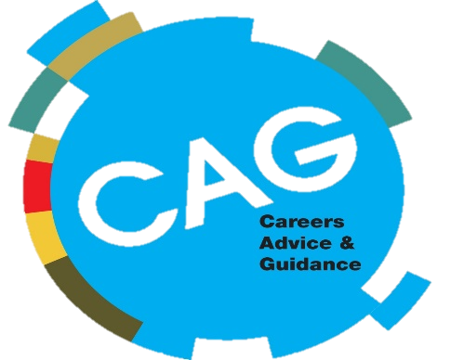
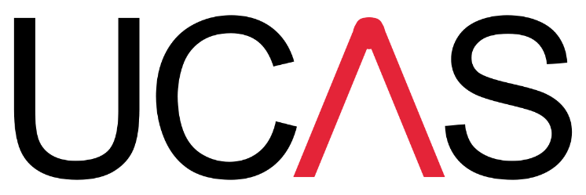

UCAS APPLICATION & PERSONAL STATEMENT HELP

WHEN: MONDAY 26TH OCT – FRIDAY 30TH OCT
WHERE: THE LEARNING EXCHANGE, ROSCOE STREET
THE CAREERS ADVICE & GUIDANCE TEAM ARE OFFERING 121 HELP WITH ALL ASPECTS OF THE UCAS APPLCATION PROCESS;
• APPLICATION FORM
• PERSONAL STATEMENTS
• RESEARCHING DEGREES
• INTERVIEW PREP

TO BOOK A PLACE CLICK THE LINK BELOW AND COMPLETE THE FORM. WE WILL THEN BE IN TOUCH TO CONFIRM YOUR APPOINTMENT.
https://forms.office.com/Pages/DesignPage.aspx?fragment=FormId%3DgrK-iRX1PkS9oChvK_iMnwtIFOCT33JAt0pmhMV5ZMlUMTgyWkVYWlE2UVVMRzFaSlk2RENJNDlJMS4u

